LAB 3

Yelubayev Ilyas

1) SELECT * FROM passengers

WHERE last_name = first_name;

In my table there is no such passangers:

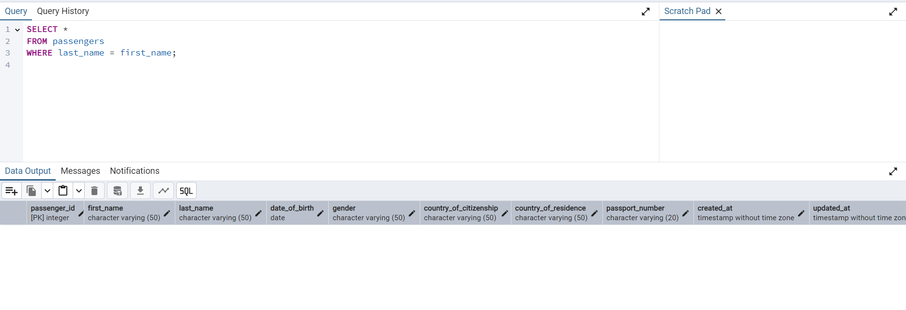2) SELECT DISTINCT last_name FROM passengers;

After this query I had 200 rows, which means that there is no duplicates among last-names:

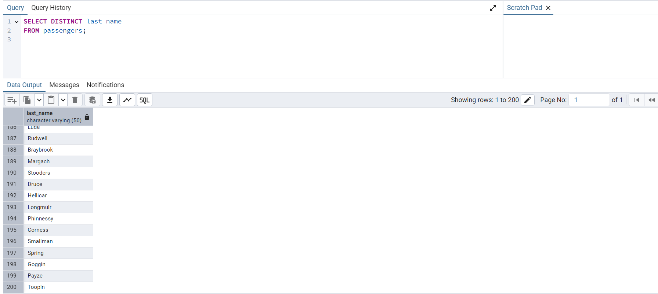

3) SELECT * FROM passengers WHERE gender = 'Male' AND date_of_birth BETWEEN '1990-01-01' AND '2000-12-31';

Изображение выглядит как текст, снимок экрана, программное обеспечение, число

Содержимое, созданное искусственным интеллектом, может быть неверным.

4) SELECT

DATE_TRUNC('month', created_at) AS month,

SUM(ticket_price) AS total_price

FROM booking

GROUP BY DATE_TRUNC('month', created_at)

ORDER BY month;

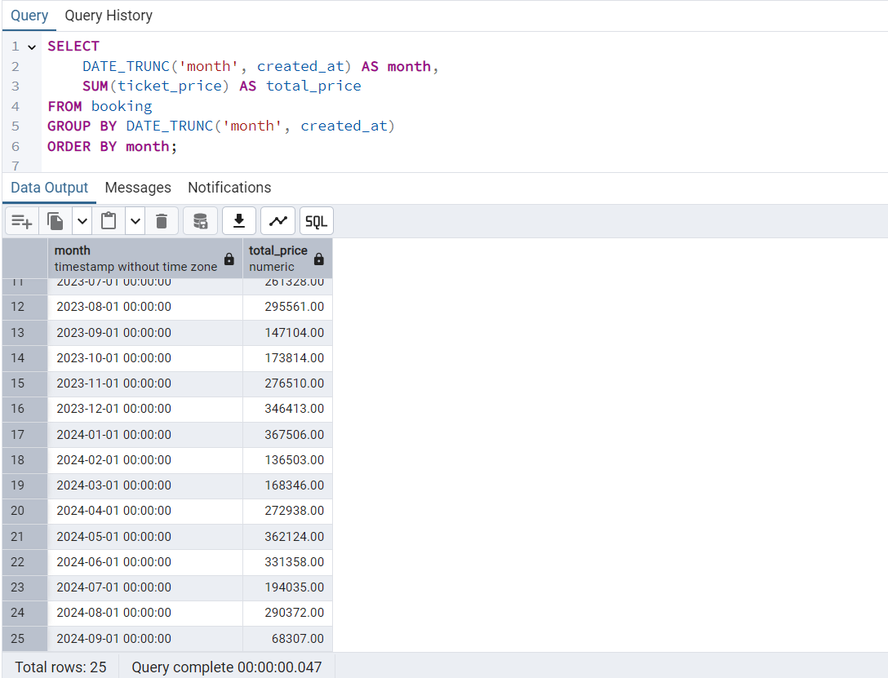

5) SELECT * FROM Flights WHERE arriving_airport_id IN (

SELECT airport_id

FROM Airport

WHERE country = 'China'

);

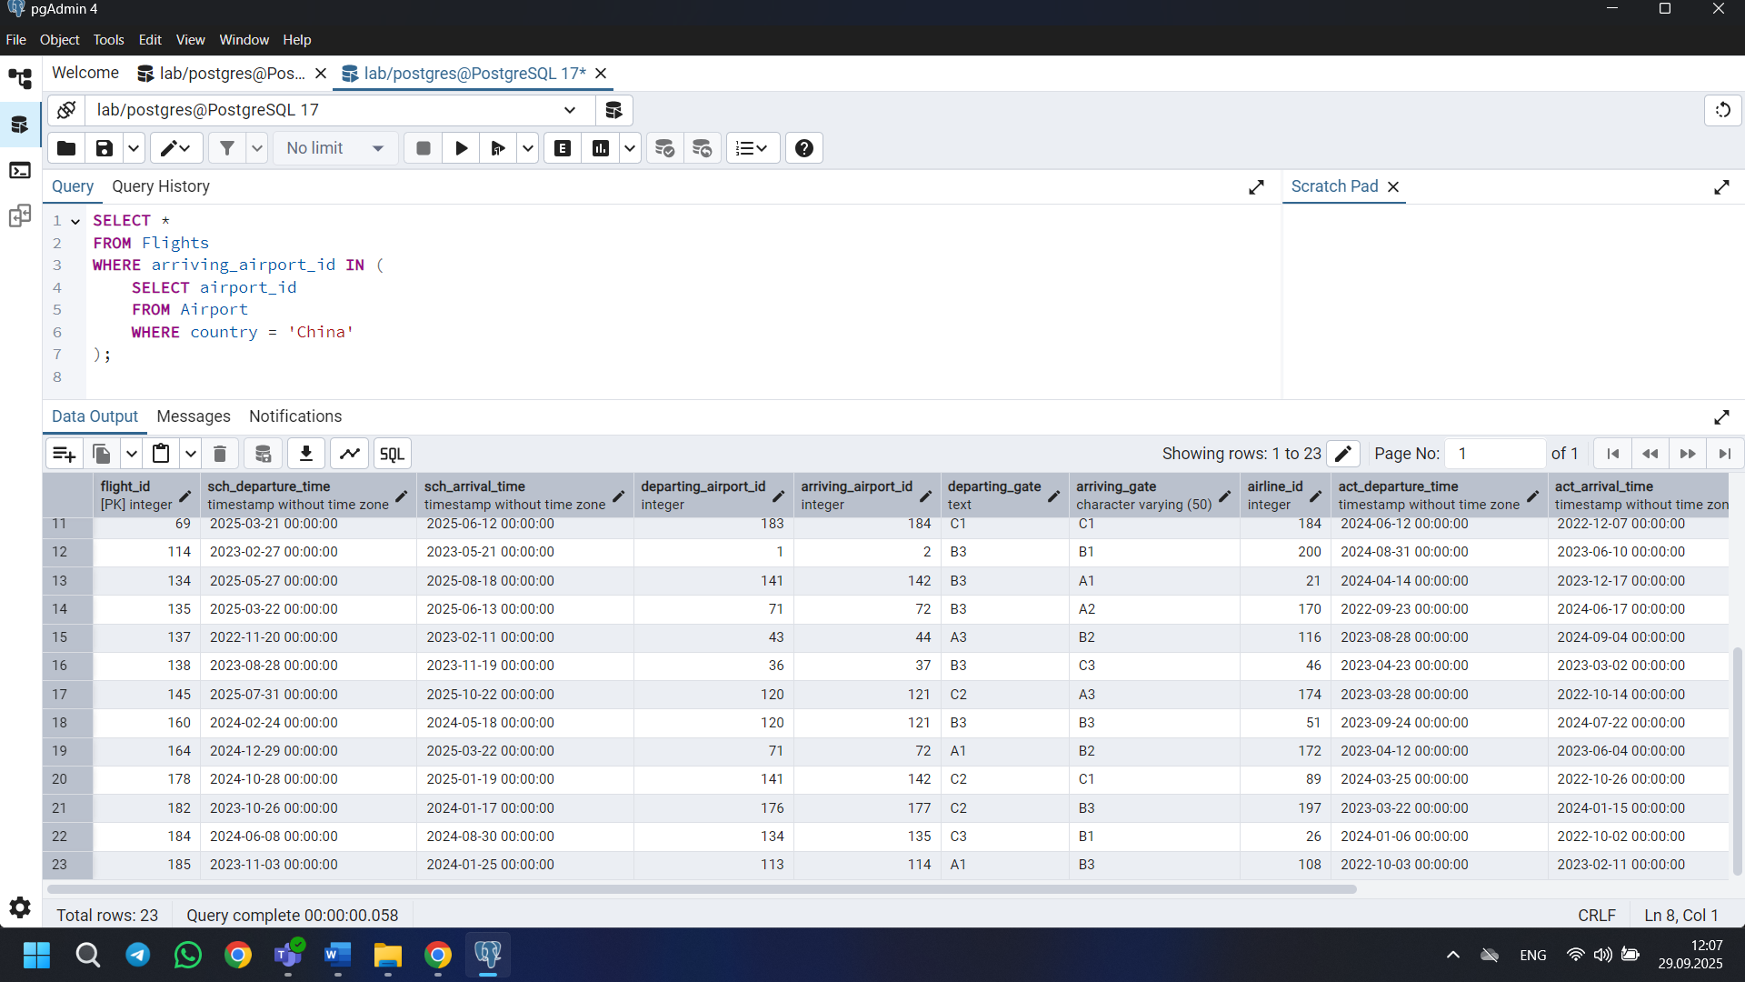

6) SELECT * FROM Airline

WHERE airline_country IN ('France','Portugal','Poland')

AND created_at BETWEEN '2023-11-01' AND '2024-03-31';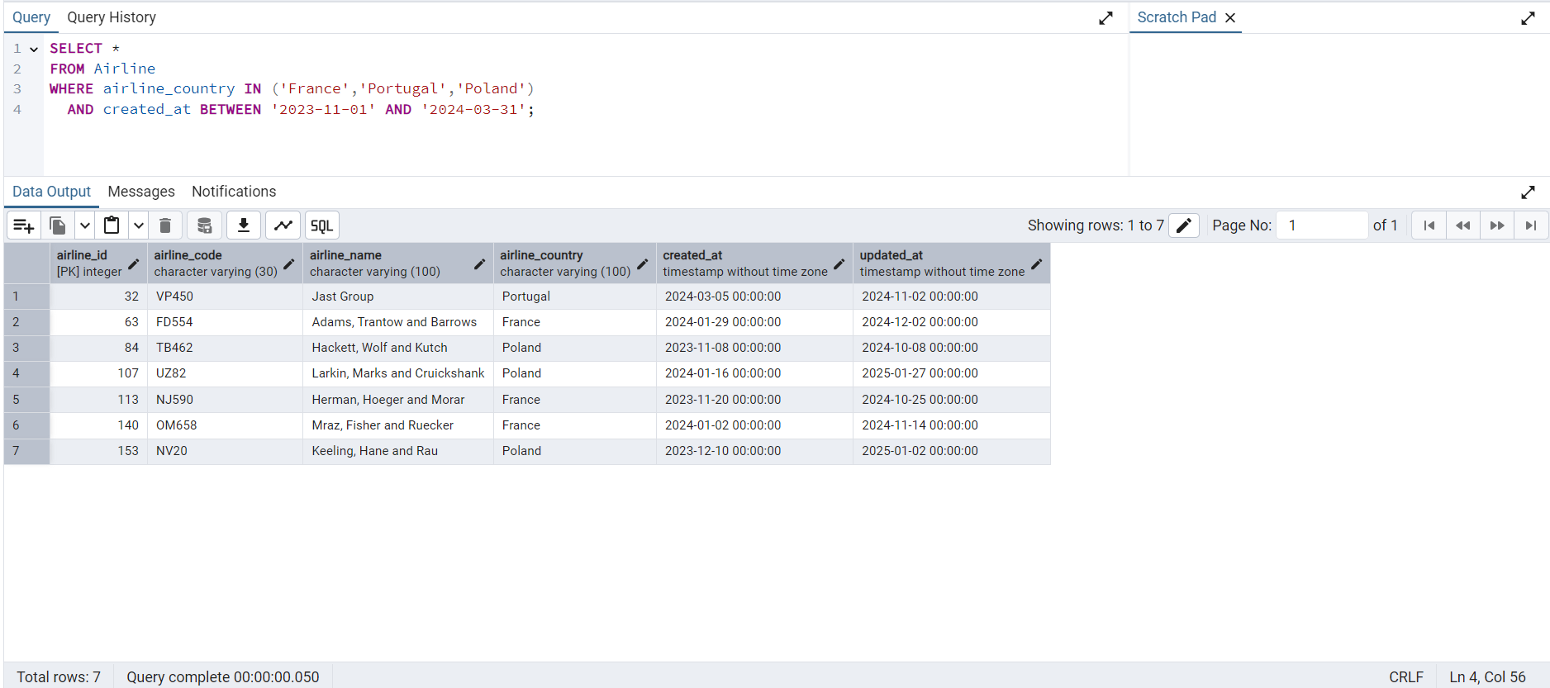

7) SELECT airline_name

FROM Airline

WHERE airline_country = 'Kazakhstan';

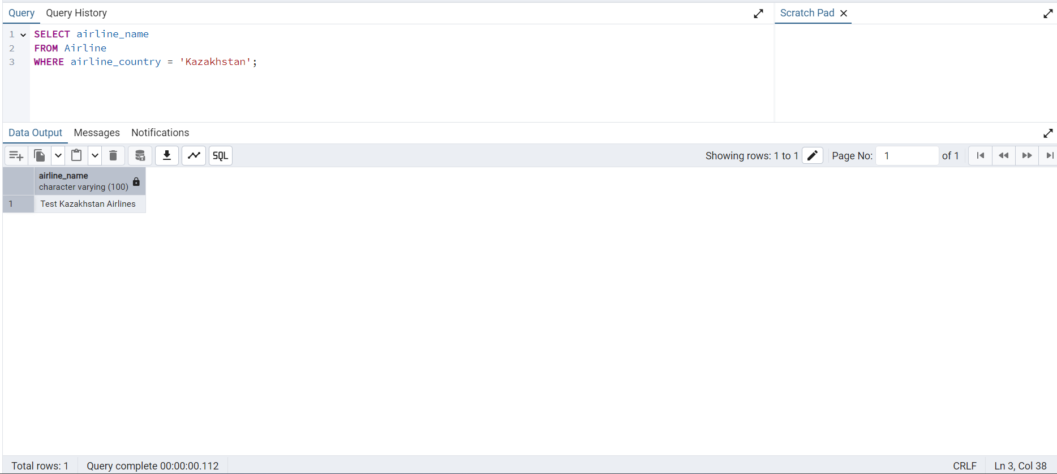

8) How it was: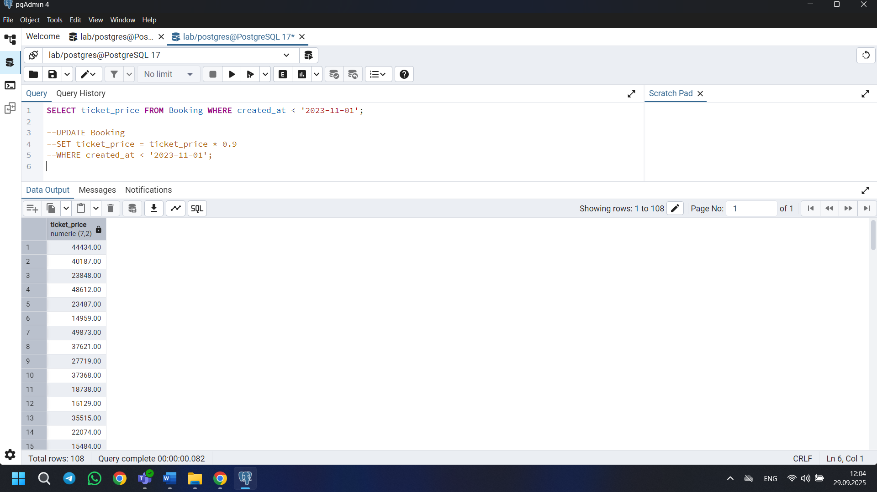

And become after:

UPDATE Booking

SET ticket_price = ticket_price * 0.9

WHERE created_at < '2023-11-01';

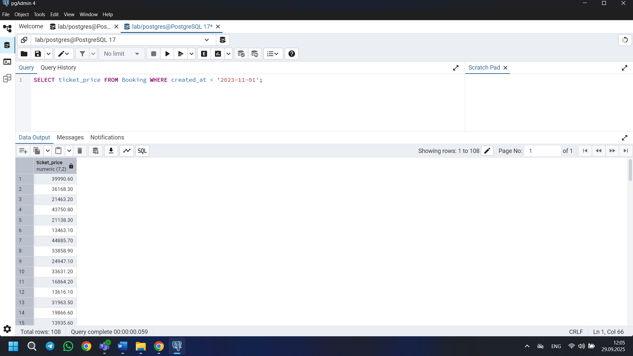

9) SELECT * FROM Baggage WHERE weight_in_kg > 25

ORDER BY weight_in_kg DESC

LIMIT 3;

Изображение выглядит как текст, снимок экрана, Шрифт, программное обеспечение

Содержимое, созданное искусственным интеллектом, может быть неверным.

10)

SELECT first_name || ' ' || last_name AS full_name,

date_of_birth

FROM Passengers

ORDER BY date_of_birth DESC

LIMIT 1;

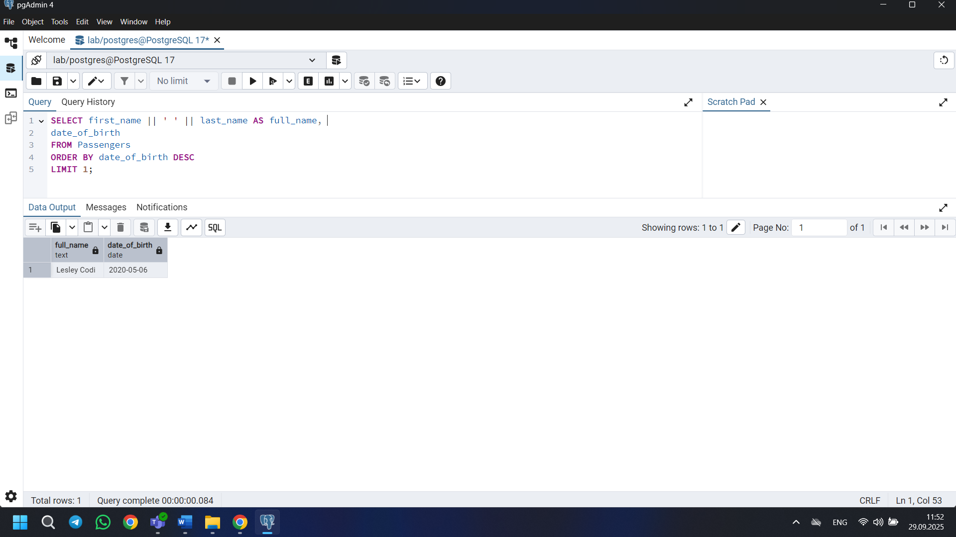

11) SELECT booking_platform, MIN(ticket_price) AS cheapest_price

FROM Booking

GROUP BY booking_platform;

Изображение выглядит как текст, снимок экрана, программное обеспечение, дисплей

Содержимое, созданное искусственным интеллектом, может быть неверным.

12) SELECT *

FROM Airline

WHERE airline_code ~ '[0-9]';

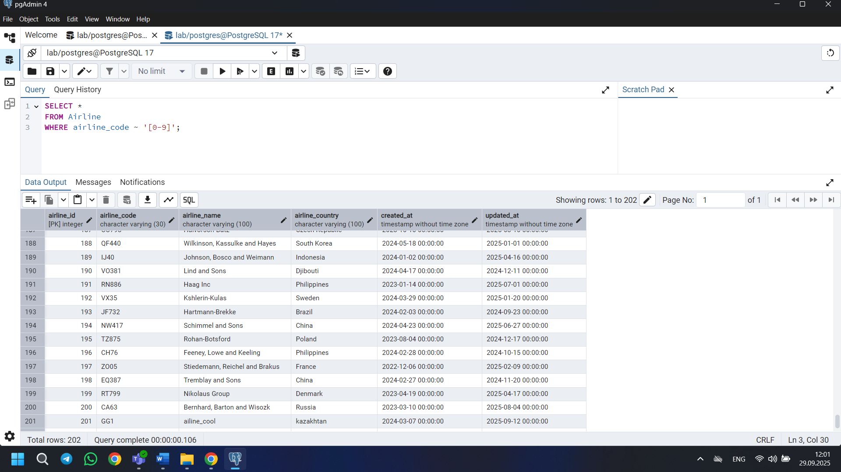

13) SELECT *

FROM Airline

ORDER BY created_at DESC

LIMIT 5;

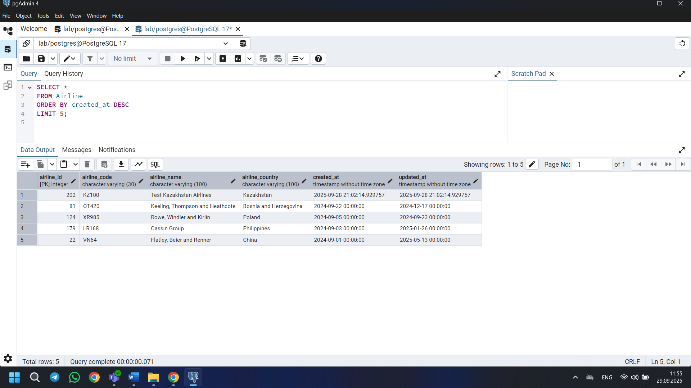

14) SELECT * FROM Baggage_check WHERE booking_id BETWEEN 200 AND 300 AND check_result = 'Checked';

In my table there is no more than 200 rows

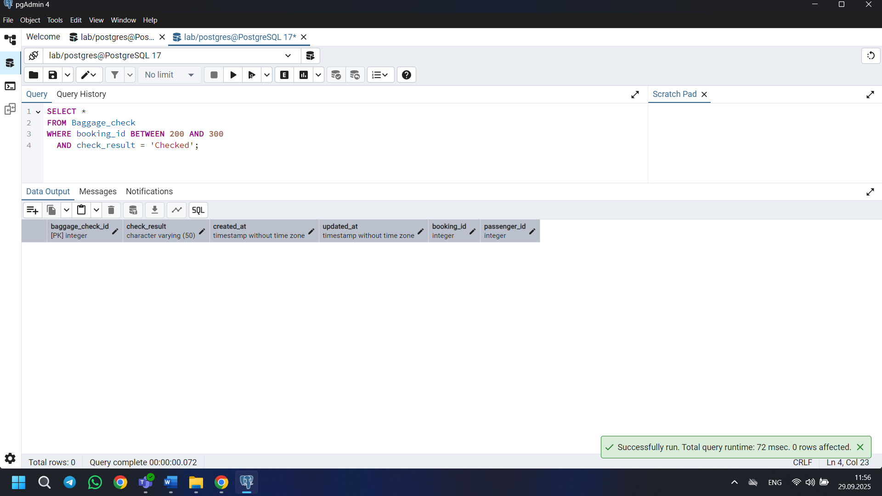

15) SELECT *

FROM Baggage_check

WHERE DATE_TRUNC('month', created_at) = DATE_TRUNC('month', updated_at)

AND updated_at < created_at; 